OUTSTANDING REQUEST

FIELDS TO ADD TO THE ADMIN: www.ACHATWITHSTARS.com

Please give us the ability to have different color fonts on

File Name
Title
Tags
Transcript
Description
Open area for links (open area text box)

REFINEMENTS TG PHASE 1

- General
  - May you please take out the optin--graphic --that at the bottom of each phase will use the opt-in that is on the actual footer-- then the actual graphic with opt-in should appear.
  - There is a typo on the footer “Signup”--should be “Sign up”
  - The featured image on the browser needs to be updated to show VLN logo- for now we see the letter “J”
  - The line of the header after VLN and Traciana Graves--needs to be removed
  - All tabs and dropdowns on the subtab and on the footer should NOT be in UPPERCASE.
  - On several subtabs the options are all in Uppercase
    - Government services
    - About VLN
    - Events
- Pls install the simple blog theme twenty seventeen
- The text is missing on all of header images
- The media logos beneath the header are the wrong size and don’t look like right quality
- All header images are not full width

- Events:https://thevlnetwork.com/tracianagraves/events/
  - Margins of header are not full width
- Training: https://thevlnetwork.com/tracianagraves/training-services/
  - Margins of header are not full width
- Government Services: https://thevlnetwork.com/tracianagraves/government-services/
  - Margins of header are not full width
  - The section with the image in the side bar and the for the capability statement is too small. The user cannot see there is an offer to download something
- Our Brands:https://thevlnetwork.com/tracianagraves/our-brands/
  - Margins of header are not full width
- About VLN:https://thevlnetwork.com/tracianagraves/about/
  - Margins of header are not full width

- Speaking page: https://thevlnetwork.com/tracianagraves/speaking-workshops/
  - The blue graphics do not match
- Home page:https://thevlnetwork.com/tracianagraves/
  - Header image is pixelated
  - The nine images that are mocked up-- and the text should appear when you hover over the
  - On Media Inquiries-- the “approved photos” should be downloadable
- Meet TG :On this page: https://thevlnetwork.com/tracianagraves/meet-tg/
  - We mocked up the color the subtab should turn when you hover over it
    - All subtabs including “music” should be the same color
ON IPAD
- The header does not have VLN or Traciana Graves
- The DROPDOWN-tabs and subtabs are not organized properly-- by main tab
  - FOUNDER TG
  - VLN
  - MINDFUL MEDIA
- The header bar is purple-- this needs to be changed
- On all pages --The optin for the offer below header has text that goes over to the CLICK HERE BUTTON
- On all pages this section is very tall and makes the header image seem very small
- Many pages have text that overflows on the subtabs

ON CELL PHONE MOBILE
- The header does not have VLN or Traciana Graves
- The DROPDOWN-tabs and subtabs are not organized properly-- by main tab
  - FOUNDER TG
  - VLN
  - MINDFUL MEDIA
- The header bar is purple-- this needs to be changed
- On all pages --The optin for the offer below header has text that goes over to the CLICK HERE BUTTON
- On all pages this section is very tall and makes the header image seem very small
- On One Sound On-- the subtabs are spaced very far apart

PHASE 2
TG FUNCTIONALITY
FUNCTIONALITY PHASE 2
- Add the following plugins
  - Yoast
  - Option for Translations
  - Facebook comments on blogs (the same that we asked you add to VLN blogs)

- Government Services: https://thevlnetwork.com/tracianagraves/government-services/
  - Please attach the downloadable capability
- Each section on every page will need an anchor url-- and some will even get domain masking
- Each subtab on every page will link an anchor link
- The call to action button underneath the header should be hyperlinked to a free offer that is on the store
- Please note that the UX for the subtabs on each page -- lead to an anchor section (that is listed already on each page. The subtabs that don’t have a section on a page are meant to link to a corresponding page on the TG site
- All videos tabs will link to a play list on youtube
- Podcasts will link to our Spofity

- NOTES
  - For TG media inquiries https://thevlnetwork.com/tracianagraves/booking-media-info/
    - we will add the photos and the download that are listed on the buttons
    - Photos need to be downloadable
    - The bio needs to be downloadable
    - The media inquiry will need to come from Dubsado
  - All CONTACT US buttons are mean to be hyber linked to the BOOKING section
  - About VLN:https://thevlnetwork.com/tracianagraves/about/
    - Margins of header are not full width
    - Book VLN Team will need a Dubsado form as mocked up

PHASE 3
STORE SET UP

STORE
- We will be selling
  - For our high ticket offers-for corporations, we want them to fill out a discovery form--where they enter they enter info about the size of their company-- and their interest. This will add them to our CRM-- and a follow up workflow--this can be done through DUBSADO
  - We will want them to be able to use social media to discuss how they are using a product
  - We will want them to be able to leave a review for a product
  - We will want to get their text info--
  - We will w
  - General
    - Taxes per each state -- in US and abroad (based on tr
    - Shipping costs by state and each country
    - Privacy terms
    - Data terms
    - Automatically--recommend additional;
    - Featured blogs

  - We will also have our different events listed
    - User can make a deposit to get on the waitlist- and then be notified- once the actual summit or course or masterclass is about to go live

  - LMS
    - The offer for each LMS will available on the store-- once the user signs up they get a code that will take them to page where they can login--
    - The “free gifts”will each have a place to sign up-- and then an immediate upsell where they can pay for a supplementary minicourse

  - Training
  - Monthly package-- this option will give one product and automatic downloads/emails and eventually lessons that are in the LMS
  - Bath and body products
    - That will have different upsell packages
      - Product for one price
      - Product plus a week of lessons/prompts
      - Product plus a month of lesson /prompts
      - Product with a book club 3 month master clase
    - The ability to recommend complimentary offers--that enhance this offer
- Google anyltics
- Each product will need to have recommended blogs that mentioned the need for this product-- as blogs are added to TG and VLN-- we will update the list of related blogs
- Need multiple tabs for the description of a product/offer
- Tagging types of content--so that we can have content aggregated by different keywords
- Adding the user/buyer to email drips
- Giving coupons
- Affiliate links

CRM/EMAIL
- Can figure out how to use DUBADO.com to create the booking and media inquiry fields
- Our store and the tg site will both have email drips that use the same service

DONE

- Use the menu tab and email opt-in that is mocked up on the MEET page-- for all of the pages

- Use Fira Sans as the font
- NOTE-- we have added the tab “SHOP” which will link to the ecommerce we would like you build on WOO COMMERCE (for phase 15). subdomain we we would like you to build on another subdomain shop.thevlnetwork.com

NOTES FOR THE FOOTER ON TG
- If you can add this footer like this--
  - the call to action for the newsletter which you see can hyper link to a page that has the form that we mocked up with fields for the name and email address

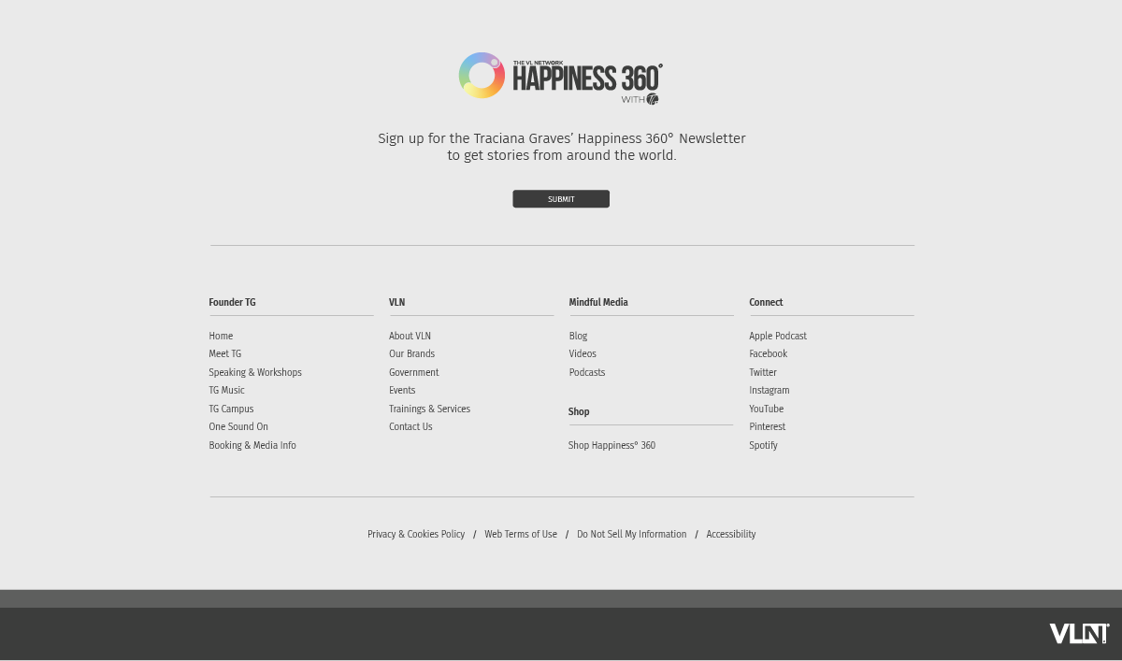

THEN can you design the mailchimp form that the user completes to look something like this:

NOTES FOR TG SITE
- This site should be on TracianaGraves.thevlnetwork.com
- There a total of 12 pages
- Pages 13-15 are mocked up to show you the subtabs
- Our opt-in for the mailing list will be using Mailchimp
- Please use the font FIRA SANS
- For the 5 VLN pages we are going to refine the headers and colors of the tabs by the end of the week-- so please get started with the HOME page and the 7 TG pages first
- As soon as TG site is finished we will be ready to move forward with finalizing VLN. We are working to simplify our requests.

